【Levi's CMS】CMS SI Project Q&A(20191018)

【Q&A】
Q1: Pixel Resolution
We got the screen size from email attachment.
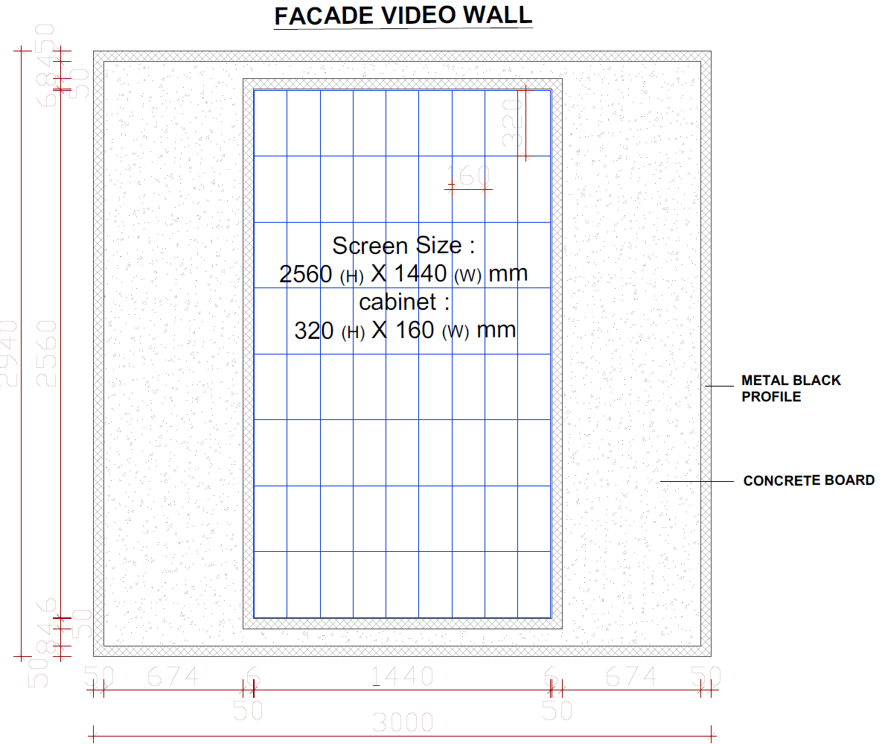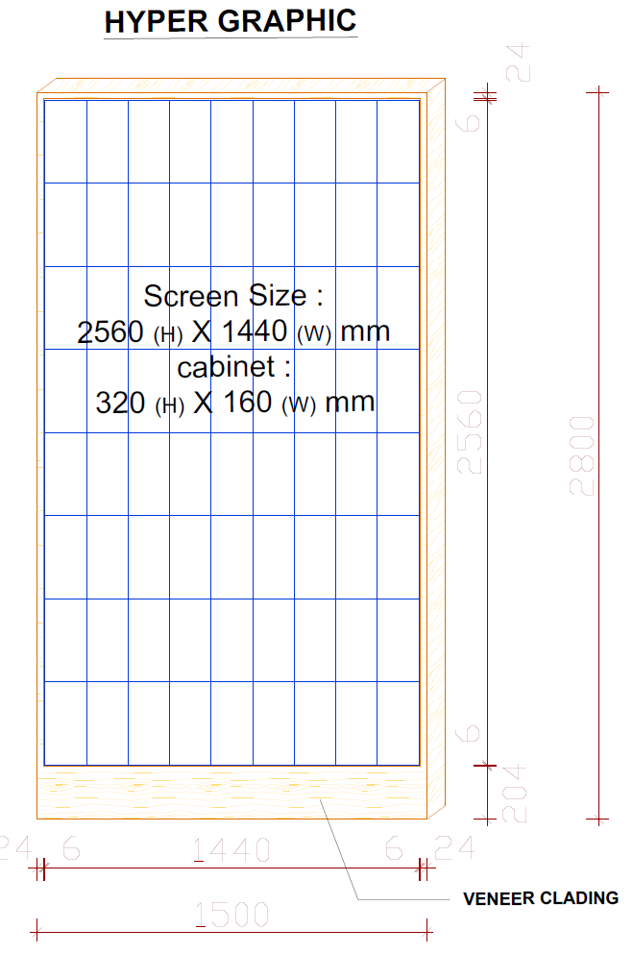
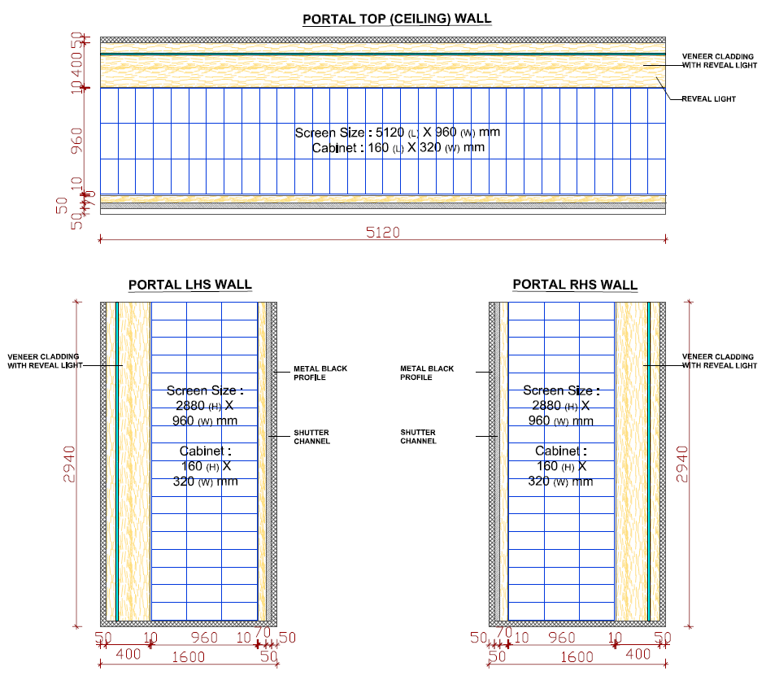
Resolution:
384px (W) X 2048px (L / H)
Resolution for both left and right walls:
384px (W) X 1152px (H)

Our media box has a display limit. The pixel resolution limit what one media box can support is 1920px * 1080px.
So, please give us the pixel resolution of every screen. – The resolutions mentioned above; all screens are of P2.5.

Q2: Equipment Installation Environment
- The appearance size of the media box is 148mm * 114mm * 34mm. You need to make sure that you have enough space for the media boxes. – We would have adequate space to accommodate.

- Our display software what support by our media box is a SaaS service by internet. The placement of the media box need reserves a network cable socket and a power socket. – Hardware requirement would be available.

- The network cables need CAT6 standard. Includes the jumper cables and the in-wall cables. – CAT 6 cable provision created at store.

- You need make sure whether the three portal walls need to be synchronized. If need we will add the router device in the equipment list. – All three portal walls nees to be synchronized.

- IF the following screen’s pixel resolution exceeds 1920px * 1080px, then we will provide two media boxes for this screen. And LED vender need to provide video splicing equipment (“two in” – “one out” or “two out”). – Will check for the unit and update.

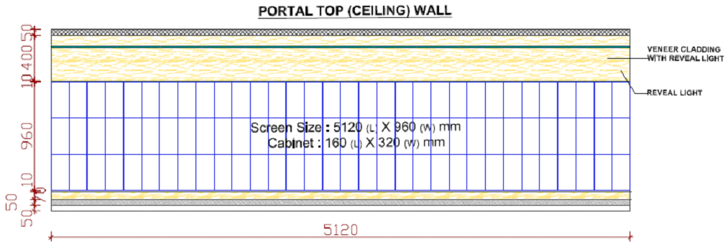

- Please check whether the store network can connect to the reverse SaaS service.
You can refer to the following documents: [V8 STB Standard Installation Requirements 2019-Network Check Manual (EN).docx]. Please reply the test result images to us. – Getting the same checked with local IT, will update.

- Please provide us the store ID and name, we will make a CMS account for the store.

- The portal top wall screen’s pixel resolution exceeds 1920px * 1080px, we will provide two media boxes for this screen like the following image. Please check whether the video splicing equipment (“two in” – “one out” or “two out”) can support HDMI.
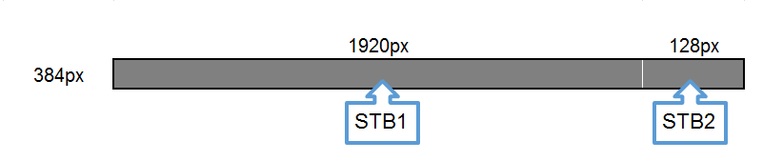

- Please tell us about the schedule of the CMS go-live.

CONFIRMER：Benjamin.Guo

DATE：2019-10-18

